Injuries in Professional and Collegiate Sports: Identifying Athletic Predisposition and Susceptibility to Injury and Analyzing Modern Incorporation of Biomedical Technology

Peter Chapman
University of Delaware
STAT468: Senior Research Project
Final Draft
Professor Bryan Crissinger
December 15, 2025

Introduction
Research Question
Professional and collegiate sports are of heavy importance in modern culture, especially to athletes, coaches, athletic trainers, and fans. One unfortunate downside to these two levels of athletics is the multitude of injuries that occur to athletes, especially in contact sports. It is generally understood that there is a multifactorial nature to injuries, which limits the ability to predict the likelihood of injury for a given athlete. Despite this limitation, there recently has been a large emphasis on researching injury risk and prevention within these two levels of athletics. Naturally, this research trend has become most popular in mainstream sports such as football, basketball, soccer, and baseball. A series of related statistical research questions arise from this growing trend. First, are there predispositions to certain injuries for athletes of a certain size, position, sport, or activity? If these predispositions exist, what is the full extent to the susceptibility to injury? The second string of questions addresses biomedical advances within these sports. From a biomedical and biomechanical perspective, what is currently being done to address injuries in professional and collegiate sports? Are the modern advancements in injury risk and prevention effective in reducing the number of injuries, especially serious incidents? Answers to the second set of questions may be more difficult to find due to the recency of these medical developments, so this series of questions acted as a secondary topic for this project. This study looks at data and research from multiple sports leagues at the two levels, including the National Football League (NFL), the National Hockey League (NHL), several major National Collegiate Athletic Association (NCAA) sports, and the English Premier League (EPL) in professional soccer.

Hypotheses
Prior to conducting research and viewing data, the hypotheses for this research project must be identified. Since there are two different series of questions asked in this research project, there are two main hypotheses. The first hypothesis relates to the first two questions about predisposition to injury and the full extent of susceptibility to injury. It is generally believed before conducting the investigation that certain internal and external factors play an important role in determining an athlete’s likelihood of injury. Internal factors include anything relating to the athlete as an individual: age, flexibility, genetics, previous injuries, and more. External factors refer to anything outside of an athlete’s control that can affect health on the field: playing surface type and conditions, opponent behavior, quality and range of protective equipment, and more. With these factors in mind, it is expected that there are statistically significant predispositions to injury. However, due to the multifactorial nature of injury, it is hypothesized that the full extent of potential susceptibility to injury can only be estimated and not perfectly calculated.
The second major hypothesis relates to the final two questions described above. As mentioned before, it is understood that quantitative research into injury risk and prevention has increased tremendously in previous years. As a product of this trend, coupled with the rise of technology into athletics, it is believed that there have been several advancements from the biomedical and biomechanical industries for athletic health purposes. It is expected that these advancements have been most prevalent for the mainstream sports with a large number of injuries (such as tackle football) or for a recurring injury that happens within a given sport (such as an elbow injury for a pitcher in baseball). There is less certainty in the hypothesis regarding the effectiveness of these biomedical and biomechanical advancements in athletics due to the perceived recency of these developments. However, due to the extensive research into sports health, and the exceptional growth in technological implementation into collegiate and professional athletics, it is optimistically believed that these advancements have reduced the number of injuries, particularly serious ones.

Motivations
The primary goal of this research project is to help identify potential causes of injuries in significant professional sports leagues across the world. Professional sports leagues and teams have prioritized research into injury prevention, specifically looking into what factors could potentially be causing certain injuries. This research study hopes to be a part of this movement into preventing injuries by determining what may be correlated with them.
The secondary goal of this study is to identify and evaluate the technological advancements that were recently implemented into collegiate and professional athletics. As mentioned before, many leagues and agencies have invested a lot of time and resources into research regarding the creation of tools that can help reduce specific injuries to a certain body part. This study hopes to find and use relevant studies and data to identify how effective these developments have been in reducing the frequency of these targeted injuries.

Literature Review and Background
Biomedical and Biomechanical Research
Before any data is collected and analyzed, research must be conducted in order to find correct biomedical information on injury prevention and risk. As mentioned before, this subject area has seen a tremendous increase in research attention over the past few years. Databases such as Academic OneFile, Google Scholar, SPORTDiscus, and DELCAT Online Catalog were used to find research articles and academic pieces relating to this research topic.

Internal Factors
A study by Zhao Wentao from Sichuan Minzu College includes an investigation into the individual factors that affect the likelihood and severity of injuries in sports. Age, health status, and physical condition all have a significant impact in determining the susceptibility of injury (Wentao). Individuals of older age are at increased risk of developing conditions such as arthritis, muscle atrophy, and more. These conditions subsequently increase the risk of sports injuries. Physical condition refers to metrics such as height, weight, bone density, gender, flexibility, etc. These factors, sometimes together, are all associated with different levels of susceptibility to injury (Wentao). Psychological factors such as self-esteem and self-identity are also important in the likelihood of injury. For example, individuals with depression or low self-esteem are at a greater risk of injury.
A similar study by Simo Taimela, Urho M. Kujala, and Kalevi Osterman echoes the findings of the previous study, specifically about age, physical condition, and psychological factors (Taimela, et al.). This study found other significant factors as well. Notably, an athlete’s injury history is a debated topic among medical experts. This study identifies that previous injuries may not be linked to a future injury, as long as the first injury was treated correctly (Taimela, et al.). If not, then certain injuries may lead to other injuries in the future, especially if the athlete has injury-prone biological characteristics. From a body size perspective, taller and/or heavier people are at a higher predisposition to injury due to a difference in center of gravity (Taimela, et al.). Those with longer limbs may also have more stress on their joints.

External Factors
A study by R. Bahr and I. Holme of the Oslo Sports Trauma Research Center and the University of Sport and Physical Education also reported the internal factors of the previous two research articles. Additionally, this research study analyzed the potential contributions of external factors as well. Referred to as external risk factors, these include human factors, protective factors, sports equipment, and environment (Bahr and Holme). Human factors act as an umbrella term for any action or event from another individual outside of the injured player. For example, teammates, referees, and opponents can all affect the likelihood of getting injured. Protective equipment, such as shin guards and helmets, includes equipment specifically designed to protect human body parts (Bahr and Holme). Sports equipment includes all other equipment that is used: baseball bats, gloves, batting gloves, skis, hockey sticks, etc. The environmental factors include the weather, snow and ice conditions, field or floor type, and the maintenance of the playing surface. All of these external factors were found to have an impact on the likelihood of an athlete getting injured (Bahr and Holme).

Multifactorial Nature of Injury
This same research study highlighted a concept called the multifactorial nature of injury. This concept states that there are many factors that could be correlated with the occurrence of an injury within an athlete. The cause of an injury in organized athletics cannot be determined due to the sheer number of possibilities behind each injury (Bahr and Holme). Rather, internal and external factors are considered to be correlated with a predisposition to injuries. Because several factors should be considered, a multivariate approach is necessary in studies such as this one that try to analyze injury risk (Bahr and Holme). Being more specific, this study recommends the use of a logistic regression model with multiple predictor variables being considered (Bahr and Holme).

Recent Advancements in Organized Athletics
Biomedical and biomechanical advancements in organized athletics have seen rapid development with the improvement in technology, especially in the 21st century. Some advancements target a specific type of injury, as opposed to injuries within a certain sport or injuries to athletes of a specific type (Nath, et al.). For example, non-contact knee injuries (including ACL, PCL, and meniscus injuries) have led to increased research into how playing surface and field upkeep affects the likelihood of injury. In particular, a focus has been placed on determining the effect that artificial and natural playing surfaces have on the likelihood of injury (Nath, et al.). Another development in addressing non-contact knee injuries is the improvements made in footwear such as cleats, basketball shoes, and ice skates.
Head injuries and concussions have also seen their fair share of research, especially due to the increased fear and awareness that athletes have regarding them. In organized football and hockey, high-tech materials such as carbon fiber and polycarbonate have recently been used to manufacture protective helmets (Nath, et al.). The most infamous helmet, the Guardian Cap, has recently been implemented within both professional and collegiate football in an effort to reduce head injuries and concussion among athletes who play tackle football.
Other advancements are general improvements and inventions across all sports. Many sports now have smart fabrics that collect vital signs, assess fatigue, and monitor the motor functions of athletes (Nath, et al.). Wearable technology such as Global Positioning System (GPS) trackers, Local Positioning System (LPS) trackers, and virtual and augmented systems record performance data such as speed, acceleration, location, and workload. Some athletic clothing items now contain embedded sensors that collect movement patterns, estimate athletic force, and measure athlete posture (Nath, et al.). The most recent development amongst all of these is the rise of artificial intelligence in injury risk and prevention. When given all of this collected data, artificial intelligence is now being used to make predictions and recommendations in order to reduce the likelihood of injuries among athletes (Nath, et al.).

Methodology
Data Collection
Data sets relating to internal and external factors as well as injury outcomes were searched for and found online for the National Hockey League (NHL), the English Premier League (EPL), the National Football League (NFL), and select NCAA sports. Unless otherwise denoted, each raw data set was downloaded or pulled into Microsoft Excel for data storage.

English Premier League Injury Outcomes
A sample of injury data from professional soccer’s English Premier League, called ‘Football Player Injury Data’, was found from the user ‘Kalpesh Kolambe’ on Kaggle [2]. This user scraped the injury data using the ‘worldfootballR’ package in R. Player attributes were taken from the FIFA video games from 2016 to 2021. This raw data set contains 30 columns and 685 observations in total. Internal factors such as age, height, weight, and body mass index (BMI) and external factors such as minutes played, position, matches played, and the number of days injured in the previous season are included in the data set. There are two potential dependent variables of interest. The first is a binary variable representing whether or not the player got injured during the season. The second is the number of days that the player missed due to injury during the season. Appendix A shows the full data dictionary for the raw English Premier League injury data set from 2016 to 2021.

NCAA Injury Outcomes
Injury outcomes for NCAA-sponsored sports were more difficult to find, as collegiate athletic departments and the NCAA itself are required by HIPAA to protect data regarding student-athletes. Fortunately, an injury-related data set was found on Kaggle that protects the identities of student-athletes. The data set, titled ‘College Sports Injury Detection” by an account called ‘Ziya’, shows an anonymous ‘Athlete ID’ instead of sharing the names of student-athletes [1]. The data comes from NCAA training sessions of different collegiate sports. Fortunately, not all student-athletes included in the data set suffered an injury during training. The purpose of this data set was to use internal and external factors to predict the risk of injury, using the injury status of the student-athletes during these training sessions. This data set of 1000 observations contains 13 columns, including biomedical metrics such as heart rate in beats per minute and respiratory rate in breaths per minute. Other key metrics include the specific sport that was played and the type of activity that was performed during the session (jumping, sprinting, etc.). Most importantly, it contains a binary classification metric that shows whether the student-athlete suffered an injury (denoted with a 1) or stayed healthy (denoted with a 0). All observations and columns were kept in this process, so the data did not need to be cleaned or transformed in a future step. Appendix B shows a full data dictionary for this raw data set.

External Factors for NFL Injuries
External factors such as playing surface, environmental factors, opponent behavior, and protective equipment are all most relevant in the National Football League (NFL). Each NFL stadium is a different experience for players when these external factors are considered. Teams can play indoors or outdoors, and they are free to choose the playing surface that they wish to play on. Of course, the playing surfaces of some fields are also determined by stadium design. If the stadium is outdoors, then the home team’s exact location may lead to specific weather conditions and other environmental effects. Because the NFL’s external factors are most relevant, the search for NFL data sets with external factors was prioritized over other leagues. In particular, the goal was to find a data set with playing surface and number of days missed for each injury. The relationship between these two is highly debated across the NFL.
Fortunately, a data set was found online that includes the playing surface of each stadium, the body part that was injured, and the severity of the injury using binary threshold variables. The user ‘JasonZivkovic’ on Kaggle scraped the data from the NFL’s archive of league plays [3]. The priority for this user was to find plays where significant lower-limb injuries happened. This data set contains 9 columns and 105 observations, which is admittedly a small sample size. Appendix C below shows the data dictionary for the raw data set found on Kaggle.
NHL Injury Trends by Position
Injury outcomes for the National Hockey League (NHL) were found from an online database called NHL Injury Viz. This website contains all NHL injuries from the 2000-2001 season to the 2025-2026 season, including the playoffs. This means that the database provides the full population of NHL injuries that occurred in the 21st century. This data set was not available as a downloadable .csv or .xlsx file, so it could only be downloaded and used in Tableau Software.
The data set includes the position group (defenseman, forward, goaltender) of the player injured, the injured body part, the year of the injury, and the number of days missed by each player. For the injured body parts, some were very specific (appendicitis, concussion, dehydration) while others were much more broad (upper-body, lower-body, mid-body, etc.). Once again, all observations and columns were kept from this database, so no data cleaning had to be performed in Tableau. Appendix D shows the data dictionary for the data set found on NHL Injury Viz.

Data Cleaning and Transformation
For data cleaning and transformation, Microsoft Power Query was utilized within Excel for removing unnecessary columns, creating new columns for the analysis, merging tables, and more. Fortunately, as mentioned above in the data collection step, not all data sets needed to be cleaned and transformed.

Finalized English Premier League Data from 2016-2021
Table 1 below shows the finalized data dictionary for the English Premier League injury data set from 2016-2021. For the data cleaning step, there were several null values for the variables that required data from previous seasons. This includes minutes played in the previous season, matches played in the previous season, and average minutes played per game in the previous seasons. It is believed that when the data was scraped, the algorithm did not properly handle players who joined the English Premier League midway through the time range of 2016 to 2021. These cells were filled with zeroes as the players did not participate in any English Premier League matches or receive any minutes prior to joining the league.
Most variables were removed, but a few were transformed from categorical variables into binary variables. Using the goalkeeper as a reference group, binary variables were created for whether or not a player in the study was a forward, midfielder, or defender. These ‘dummy’ variables allowed for the categorical variable of position to be interpreted numerically. Internal factors kept were age and body mass index (BMI). The external factors kept were minutes played in the season, days missed due to injury in the previous season, and the aforementioned binary variables for position. The outcome variable of interest kept was the number of days the player missed due to injury.

Variable | Description and Units
season_days_injured | Number of days missed in the season due to injury
season_minutes_played | Number of minutes player received on the field for the current season
age | Player age in relevant season
BMI | Body mass index of player
season_days_injured_prev_season | Number of days missed due to injury in the previous season
isForward | Binary variable representing if the player is a forward or not: 1 if a forward, 0 if not
isMidfielder | Binary variable representing if the player is a midfielder or not: 1 if a midfielder, 0 if not
isDefender | Binary variable representing if the player is a defender or not: 1 if a defender, 0 if not
Table 1: Data dictionary for the cleaned and transformed 2016-2021 EPL injury data.

Finalized NCAA Injury Outcomes Data
While the data did not need to be cleaned, the data set with the NCAA injury outcomes needed some transformations for the categorical variables that are useful for interpretation. Table 2 below shows the finalized data dictionary for the sample of training sessions across the NCAA. Internal factors such as heart rate in beats per minute, respiratory rate in breaths per minute, skin temperature in degrees Celsius, cumulative fatigue index, and blood oxygen level percentage were kept. External factors such as session duration in minutes and force of impact of the session in Newtons were also kept. Using the sport type, a binary variable was created to measure if the sport played had heavy contact or not. If the sport played during the training session was football, then this variable took on a value of 1. If it was any other sport, the variable took on a value of 0. Another binary variable was created to measure if the sport played had mild contact of any form. If the sport played was soccer or basketball (two sports that have mild contact during training), then the variable took on a value of 1. If any other sport was played, this variable for mild contact took on a value of 0. Finally, a third binary variable was created from the intensity of the activity that was performed. If the activity type was running or sprinting, then the binary intensity variable took on a value of 1. For any other activity, the variable took on a value of 0.
Variable | Description and Units
Heart_Rate_BPM | Heart rate in beats per minute
Respiratory_Rate_BPM | Respiratory rate in breaths per minute
Skin_Temperature_C | Athlete’s skin temperature in degrees Celsius
Blood_Oxygen_Level_Percent | Percentage of blood oxygen saturation
Impact_Force_Newtons | Force of impact during the training session, measured in Newtons
Cumulative_Fatigue_Index | A calculated index representing the athlete’s fatigue level
Duration_Minutes | Duration of the training session in minutes
Injury_Risk_Score | A calculated score representing the risk of injury
Injury_Occurred | Binary variable indicating whether an injury during the session (1 for injury, 0 for no injury)
isHeavyContact | Binary variable indicating whether or not the sport contained heavy contact (1 for football, 0 for any other)
isMildContact | Binary variable indicating whether or not the sport contained mild contact (1 for soccer or basketball, 0 for any other)
isIntense | Binary variable indicating whether or not the activity performed was intense (1 for running or sprinting, 0 for any other)
Table 2: Data dictionary for the transformed NCAA injuries data set.

Finalized NFL Playing Surface and Injury Severity Data Set
Table 3 below shows the finalized data dictionary for the NFL data set containing the playing surface, body part, and injury severity. The threshold variables for the number of days missed were renamed, as the old variable names were not very clear. The categorical variables for the injured body part and playing surface were recreated using binary variables. If the playing surface was synthetic, then the ‘isSynthetic’ variable took on a value of 1. If the playing surface was natural, then it took on a value of 0. If the injured body part was the knee, then the ‘isKnee’ variable took on a value of 1. If the injured body part was the foot or ankle, then the variable took on a value of 0.
Variable | Description and Units
DaysMissed1 | Binary variable representing if the player missed at least 1 day (1 if the player did, 0 if the player missed 0 days)
DaysMissed7 | Binary variable representing if the player missed at least 7 days (1 if the player did, 0 if not)
DaysMissed28 | Binary variable representing if the player missed at least 28 days (1 if the player did, 0 if not)
DaysMissed42 | Binary variable representing if the player missed at least 42 days (1 if the player did, 0 if not)
isSynthetic | Binary variable representing if the playing surface of the injury was synthetic (1 if synthetic, 0 if natural)
isKnee | Binary variable representing if the body part injured was the knee (1 if knee injury, 0 if injury to ankle or foot)
Table 3: Data dictionary for the finalized NFL external factors data set.

Statistical and Data Analysis
The finalized data sets were analyzed in an attempt to determine which internal and external factors contributed most to the likelihood of an injury and the extent of an injury. As with most other research projects, the statistical significance was considered as an evaluation technique for each model and predictor variables in each model. A standard confidence level of 95% was used for this threshold. Due to the topic of this study being injuries and the health of athletes, a model or predictor variable may have been considered clinically significant in this project even if it was not considered statistically significant.

EPL Predictive Model for Injury Days Missed
To measure the effects of external and internal factors on injuries in professional soccer, a traditional multiple linear regression model was created using R programming. The dependent variable used was the number of days missed in the season due to injury. This variable obviously shows if a player was injured or not, but the number of days missed also allows for the true extent of the injury to be considered. Predictor variables included minutes played in the previous season, age, body mass index (BMI), days injured in the previous season, and the three binary variables representing a player’s position. The equation below shows the multiple linear regression model used for this data.
$${SeasonDaysInjured}_{Player, Year}=β_{0}+β_{1}{SeasonMinutesPlayed}_{Player, Year}+β_{2}{Age}_{Player, Year}+β_{3}{BodyMassIndex}_{Player, Year}+β_{4}{DaysInjuredPreviousSeason}_{Player, Year}+β_{5}{isForward}_{Player, Year}+β_{6}{isMidfielder}_{Player, Year}+β_{7}{isDefender}_{Player, Year}+ε_{Player, Year}$$
A residual analysis for this model was also performed in Statistical Analysis Software (SAS). There were four assumptions evaluated by the residual analysis: correct model specification, independence of errors, constant variance of errors (homoskedasticity), and the normality assumption of errors. To evaluate the normality assumption of errors, a normal probability plot of residuals was constructed. To test the independence of errors assumption, the residuals were plotted by the order in which the observations happened. For the constant variance of errors assumption, the predicted values were plotted against the residuals. Finally, the correct model specification assumption was evaluated by plotting the residuals against each of the individual predictor variables in the model.

Binary Logistic Regression Model for NCAA Injuries
The response variable of interest for the NCAA injury data set was whether or not the player suffered an injury during the training session that was conducted. This dependent variable had only two outcomes (1 for an injury, 0 for no injury) and therefore was not fully continuous. The standard multiple linear regression model was not appropriate for this problem.
Instead of a multiple linear regression model, a binary logistic regression model was implemented in Statistical Analysis Software (SAS). The equation below shows the logit transformation of the logistic regression function model for the probability of an NCAA athlete from the sample suffering an injury during the training session. The probability of interest was the likelihood of the student-athlete suffering from an injury during the training session that they were participating in. Relevant predictor variables for internal factors included heart rate in beats per minute, respiratory rate in breaths per minute, skin temperature in degrees Celsius, and blood oxygen level percent. External factors included session duration in minutes, impact level of the training session in Newtons, and the contact and intensity levels of the training session.
$$\ln\left[\frac{{P\left(injury\right)}_{Athlete, Session}}{1-{P\left(injury\right)}_{Athlete, Session}}\right] ={β_{0}+β}_{1}{HeartRate}_{Athlete, Session}+β_{2}{RespiratoryRate}_{Athlete, Session}+β_{3}{SkinTemperature}_{Athlete, Session}+β_{4}{BloodOxygenLevel}_{Athlete, Session}+β_{5}{ImpactForce}_{Athlete,Session}+β_{6}{CumulativeFatigueIndex}_{Athlete, Session}+β_{7}{SessionDuration}_{Athlete, Session}+{β_{8}isHeavyContact}_{Athlete, Session}+{β_{9}isMildContact}_{Athlete, Session}+{β_{10}isIntense}_{Athlete, Session}$$
The odds were converted back to probability using the equation below. This easily allowed for interpretation, as each individual metric then had a predictive likelihood of the athlete suffering from an injury during the training session.
$${P(injury)}_{Athlete, Session}=\frac{{Odds}_{Athlete, Session}}{(1+{Odds}_{Athlete, Session})}$$
Before the binary logistic regression was conducted, the predictor variables in the model were checked for multicollinearity. It was expected that a few of the variables for internal factors would be linearly related to each other before the regression was even performed. For this project, a condition number above 1000 was used as the threshold for multicollinearity. If the variance inflation factor was greater than 10, then multicollinearity was considered severe among predictors. This step, run just before the regression, was also completed using Statistical Analysis Software (SAS).

NFL Playing Surface and Injury Severity Binary Logistic Regression Model
In a similar method to the NCAA injury model, a binary logistic regression model was used to determine the effects of playing surface and injured body part on the severity of an NFL injury from the perspective of days missed. The equation below shows the logit transformation of the logistic regression model. For the purposes of this regression model, the dependent variable was the binary variable representing whether or not the player missed at least 42 days from their injury. This means that the probability of interest was the likelihood of a player missing at least 42 days from an injury. This was the most extreme injury outcome from the finalized data set, which may be of interest to the NFL and its teams as they look to reduce the number of severe injuries. As with the previous model, the odds ratio was considered to allow for interpretations of the two predictor variables.
$$\ln\left[\frac{{P\left(Min42DaysMissed\right)}_{Athlete, Injury}}{1-{P\left(Min42DaysMissed\right)}_{Athlete, Injury}}\right]={β_{0}+β}_{1}{isSynthetic}_{Athlete, Injury}+β_{2}{isKnee}_{Athlete, Injury}$$
Data Visualizations for NHL Injury Outcomes by Position
To identify injury trends in the National Hockey League from the 2000-2001 to 2025-2026, Tableau Software was used to make data visualizations. First, a heat map of injury frequencies was created for the three main position groups (forwards, defensemen, and goaltenders). For each injury type, the number of injuries was added together for each of these three positions across the entire time period. In order to keep things visually concise, a filter was applied in Tableau Software to allow for certain injuries to be the center of focus. Instead of focusing on minor and uncommon injuries, the heat map constructed was limited to just major injuries, including those in the upper-body, lower-body, mid-body, knee, leg, arm, and more.
The second data visualization created was a line graph that plotted the total number of injuries by position group for each year from the 2000-2001 season to the 2024-2025 season. The 2025-2026 season was excluded from the analysis, as the season is still ongoing as of the creation of this analysis. Including this partial season in the analysis would visually alter the findings, as the current season almost certainly has fewer injuries than the rest of the seasons in the data set.

Evaluation of Guardian Caps in Professional and Collegiate Football
The original goal was to find data that detailed the effectiveness of the Guardian Cap helmets in preventing head injuries and concussions in collegiate and professional football. It was very difficult to find public data for this development, especially due to the recency of its implementation into tackle football. As an alternative, two research studies were found online that test the effectiveness of these new helmets.
The first research study was conducted by Christopher Carratu, a player on the Massachusetts Institute of Technology collegiate football team. Carratu used two different tests to evaluate his teammates: a visual response test and a physical perception test (Carratu). The Guardian Cap helmets were optional, so players were naturally sorted into a control group (those who did not wear the Guardian Cap) and a treatment group (those who did wear the Guardian Cap). Student-athletes in both groups were tested during the season and the offseason.
The research study at the NFL level occurred during the testing period of the Guardian Cap NXT, one of the first models of the Guardian Cap helmets (Funk, et al.). Researchers attended preseason practices from 2018 to 2023, with exclusions made for the 2020 preseason due to the coronavirus pandemic. In 2022, the NFL instituted a new rule that required all linemen, linebackers, and tight ends to wear a Guardian Cap NXT during preseason practices (Funk, et al.). The researchers essentially used this rule to measure the impact that the Guardian Caps had on the concussion rates for these three position groups. Within the study itself, controls were included to isolate the effect of Guardian Cap usage on player concussion rate (Funk, et al.). These control variables included player position (linemen, linebacker, or tight end) and the level of intensity at practice (pads or no pads).

Results and Discussion
EPL Multiple Linear Regression Results
Table 4 below summarizes the multiple linear regression results for the English Premier League model with the number of injury days missed in the season as the dependent variable. Internal factors in this regression include age and body mass index (BMI). External factors include minutes played in the season, days injured in the previous season, and the player’s position. As expected from the multifactorial nature of injury, the model achieved an adjusted R-squared of just 11.39%, so the model is not highly predictive of the number of days that a player misses due to injury. Despite the model being weak, several variables could be considered significant. Minutes played in the season and days injured in the previous season are statistically significant in the model. Age, along with the binary variables representing the different positions, may also be considered clinically significant by those with medical expertise.
Variable | Coefficient | P-Value
Intercept | 88.569744 | 0.01616
Season Minutes Played | -0.027323 | <0.0001
Age | 0.969747 | 0.10979
Body Mass Index (BMI) | -0.496373 | 0.75396
Days Injured in Previous Season | 0.086429 | 0.00467
isForward | 10.634257 | 0.26964
isMidfielder | 12.337696 | 0.16918
isDefender | 17.0408 | 0.05643
Table 4: Multiple linear regression results for the 2016-2021 EPL injury sample, with the dependent variable being the number of injury days missed in the season.

Using the estimated coefficients from the table, the equation below shows the predictive model with injury days missed in a season as the dependent variable. These estimates can be used to make interpretations about the effects of internal and external factors on days missed due to injury during the English Premier League from 2016 to 2021. Surprisingly, an additional 100 minutes played in a season is correlated with a decrease in the number of days missed by 2.7323. The direction of this effect is shocking, which suggests that there may be a lurking variable (or a few) missing from this model. On the other hand, experienced players who receive more minutes may also know how to protect their bodies in comparison to players who are younger or less technically skilled. An increase by one year in player age is correlated with almost a full additional day missed in the season due to injury. A player whose body mass index increases by 10 is predicted to miss 4.96373 fewer days. An additional day missed in the previous English Premier League season is correlated with an increase in days missed by 0.086429. For the binary variables representing positions, the reference group consists of all goalkeepers. Being a forward, as opposed to being a goalie, is associated with 10.634257 additional days missed. Being a midfielder, as opposed to a goalie, is associated with 12.337696 additional days missed during the season. Being a defender, as opposed to being a goalie, is associated with 17.0408 additional days missed. These estimated positional coefficients suggest that defenders miss the most time, followed by midfielders, forwards, and then goalkeepers. Notably, these regression findings should be considered correlations and not causal effects. Due to the multifactorial nature of injury and the likely existence of lurking variables missing from the model, these effects are not perfectly causal. More experimental control is needed for causal effects to be estimated.
$${SeasonDaysInjured}_{Player, Year}=88.568744-0.{027323SeasonMinutesPlayed}_{Player, Year}+0.{969747Age}_{Player, Year}-0.{496373BodyMassIndex}_{Player, Year}+0.{086429DaysInjuredPreviousSeason}_{Player, Year}+10.{634257isForward}_{Player, Year}+12.{337696isMidfielder}_{Player, Year}+17.{0408isDefender}_{Player, Year}$$

Appendix E shows the residual analysis performed for this English Premier League multiple linear regression. The first visual this appendix includes is a normal probability plot of residuals. Generally, the calculated residuals are lying along or close to the reference line, which suggests that the normality assumption is fair for this multiple linear regression model. The second graph shows the predicted values versus the residuals for each observation included in the regression model. For the most part, there exists a random fluctuation of data points centered around zero. Notably, a majority of the data points are located below zero, which suggests that the homoskedasticity assumption is not perfectly satisfied for this multiple linear regression. The third figure in this residual analysis contains the plots of the residuals versus each of the individual predictor variables included in the model. Once again, decent fluctuation exists around zero for each of the predictors in the model. Like the last plot, many of these data points are located below zero; this indicates that a different model specification could perform better for this problem. Finally, the independence of errors test is the last figure in Appendix E. Random fluctuation does exist around zero, and there isn’t a major pattern that can be drawn from the data points. Therefore, it is reasonable to conclude that the independence of errors assumption has been satisfied by this model.

NCAA Injuries Binary Logistic Regression Model Results
Appendix F shows the full SAS results for the multicollinearity checks among the predictor variables. The variance inflation factors quickly reached extremely high values, which suggested that there are significant linear dependencies amongst the predictors in the model. In particular, strong collinearity existed between two pairs of internal factors. First, blood oxygen level percentage and skin temperature in degrees Celsius were very strongly dependent on each other. Second, heart rate in beats per minute and respiratory rate in breaths per minute were also strongly dependent on each other. Because these dependencies were so strong, the determined solution was to remove one variable from each pair. In this case, respiratory rate in breaths per minute and skin temperature in degrees Celsius were removed from the binary logistic regression model. For interpretation, respiratory rate can be considered with heart rate and skin temperature can be considered with blood oxygen level percent.
Table 5 and the equation below show the results of the NCAA binary logistic regression model performed in Statistical Analysis Software (SAS). Statistically significant factors include blood oxygen level percentage, force impact of the training session in Newtons, and cumulative fatigue index during the session. Surprisingly, the duration of the training session was not statistically significant. The binary variable for heavy contact, which represents whether or not the sport played was football, is right on the threshold for the significance level of 95%. To some, this may suggest that the binary variable for heavy contact is clinically significant.
Variable | Coefficient | P-Value
Intercept | 13.315 | <0.0001
Heart Rate (BPM) | -0.00279 | 0.3334
Blood Oxygen Percent Level | 0.1196 | <0.0001
Impact of Force (N) | -0.00597 | 0.0001
Cumulative Fatigue Index | -1.9031 | <0.0001
Duration of Session (min) | -0.00162 | 0.6241
isHeavyContact | 0.3394 | 0.0606
isMildContact | -0.0294 | 0.8452
isIntense | -0.124 | 0.365
Table 5: Binary logistic regression results for the NCAA injury sample, with the dependent variable being whether or not the player suffered an injury during the training session.
$$\ln\left[\frac{{P\left(injury\right)}_{Athlete, Session}}{1-{P\left(injury\right)}_{Athlete, Session}}\right]= =13.315-0.00279{HeartRate}_{Athlete, Session}+0.1196{BloodOxygenLevel}_{Athlete, Session}-0.00597{ImpactForce}_{Athlete,Session}-1.9031{CumulativeFatigueIndex}_{Athlete, Session}-0.00162{SessionDuration}_{Athlete, Session}+{0.3394isHeavyContact}_{Athlete, Session}-{0.0294isMildContact}_{Athlete, Session}-{0.124isIntense}_{Athlete, Session}$$

Table 6 below shows the odds ratio estimates for each of the predictor variables included in the binary logistic regression model. If a predictor variable had no impact on the likelihood of injury, it would have a point estimate of 1. Therefore, these estimates can be used to quantify the correlated impacts of the internal and external factors on the odds of an NCAA student-athlete suffering an injury. When a student-athlete’s heart rate increases by one beat per minute during the training session, the odds of an injury are predicted to decrease by 0.3%. A student-athlete having a blood oxygen level that is 1% higher is predicted to have 11.3% lower odds of an injury during the training session. An increase by one Newton of force impact during the training session is predicted to decrease the odds of injury by 0.6%. By a large margin, the variable with the largest impact on the probability of an injury occurring was cumulative fatigue index. Bizarrely, a student-athlete having a cumulative fatigue index increase by one is predicted to decrease the odds of an injury by 85.1%. Another shock was that the duration of the session in minutes did not make much difference in the odds of an injury. A student-athlete who trains for one minute longer is predicted to have a 0.2% decrease in the odds of an injury during the training session. The only variable to drastically increase the likelihood of injury was the binary variable for heavy contact. Playing a sport with heavy contact such as football, as opposed to other sports, is predicted to increase the odds of an injury occurring by 40.4% during the training sessions. The same increased effect was not the case for the binary variable for mild contact. Playing a sport with mild contact such as soccer or basketball, as opposed to other sports, is predicted to decrease the odds of an injury occurring during the training session by 2.9%. Finally, performing an intense activity such as running or sprinting, as opposed to other activities, is predicted to decrease the odds of an injury occurring by 11.7%. Like the findings of the English Premier League multiple linear regression, these results are correlations and not causal effects. More experimental control would be needed to make any causal conclusions from this binary logistic regression.
Variable | Point Estimate
Heart Rate (BPM) | 0.997
Blood Oxygen Percent Level | 0.887
Impact of Force (N) | 0.994
Cumulative Fatigue Index | 0.149
Duration of Session (min) | 0.998
isHeavyContact | 1.404
isMildContact | 0.971
isIntense | 0.883
Table 6: Point estimate results for the NCAA injury binary logistic regression model, with the dependent variable being whether or not the player suffered an injury during the training session.

NFL Playing Surface and Injury Severity Binary Logistic Regression Results
Table 7 and the equation below show the results of the NFL binary logistic regression model performed in Statistical Analysis Software (SAS). At the 5% level, neither the playing surface nor the location of the lower-limb injury had a statistically significant impact on the likelihood of missing at least 42 days due to injury. However, these factors could still hold clinical significance due to this being a health and safety setting.
Variable | Coefficient | P-Value
Intercept | 0.7832 | 0.0466
isSynthetic | -0.1642 | 0.7119
isKnee | 0.3992 | 0.3682
Table 7: Binary logistic regression results for the NFL injury sample, with the dependent variable being whether or not the player missed at least 42 days due to injury.
$$\ln\left[\frac{{P\left(Min42DaysMissed\right)}_{Athlete, Injury}}{1-{P\left(Min42DaysMissed\right)}_{Athlete, Injury}}\right]= 0.7832-0.1642{isSynthetic}_{Athlete, Injury}+0.3992{isKnee}_{Athlete, Injury}$$

Table 8 below shows the odds ratio estimates for both of the predictor variables included in the NFL binary logistic regression model. Once again, if a predictor variable had no impact on the likelihood of an injury resulting in at least 42 days missed, it would have a point estimate of 1. Suffering an injury on a field with a synthetic surface, as opposed to a natural surface, is predicted to decrease the odds of the injury resulting in at least 42 days missed by 15.1%. This is somewhat of a surprising finding, as many NFL fans and players believe that synthetic surfaces such as artificial turf are associated with severe lower-limb injuries. As opposed to a foot or an ankle injury, a knee injury is predicted to increase the odds that the player misses at least 42 days by 49.1%.

Variable | Point Estimate
isSynthetic | 0.849
isKnee | 1.491
Table 8: Point estimate results for the NFL injury binary logistic regression model, with the dependent variable being whether or not the player missed at least 42 days due to injury.

NHL Injury Outcomes by Position Results
Figure 1 below shows the heat map of injury frequency for each of the three main position groups in the NHL: defensemen (D), forwards (F), and goaltenders (G). When considering the injuries that were considered for this graphic, forwards have suffered the most injuries in the NHL from the start of the 2000-2001 season to now. In particular, forwards suffered a high frequency of lower-body, upper-body, knee, shoulder, and groin injuries during this time period. Defensemen suffered the second-highest frequency of injuries amongst the three position groups. Once again, lower-body and upper-body injuries plagued defensemen the most during this time period. Finally, goaltenders suffered the lowest frequency of injuries. Although they didn’t suffer many, the data visualization created suggests that lower-body and knee injuries harmed goaltenders the most frequently during this time period.
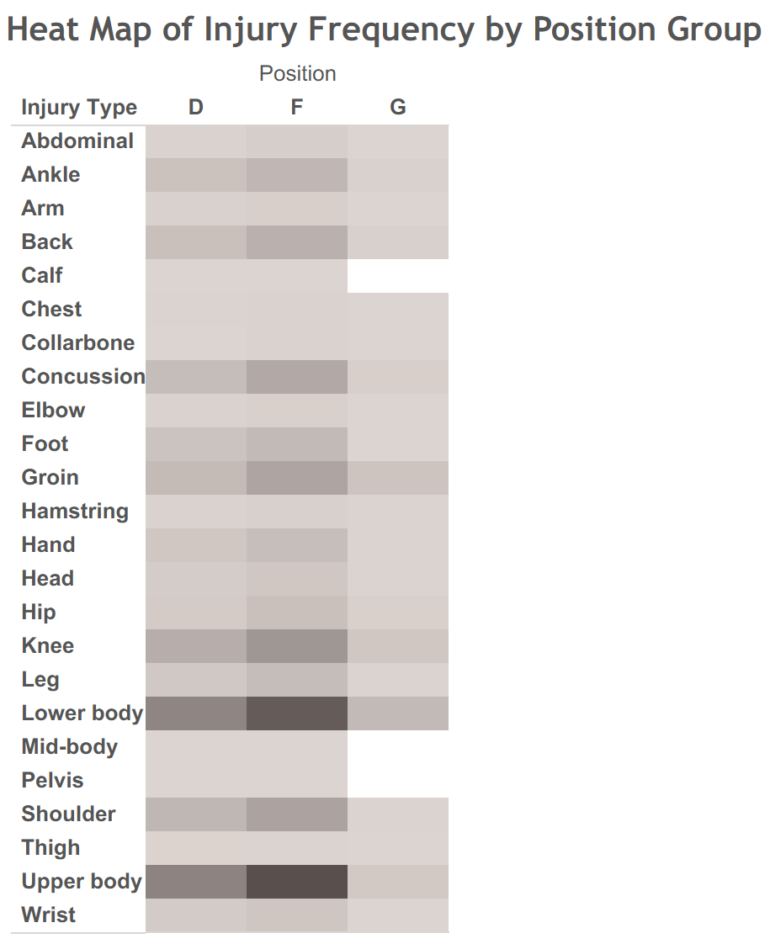
Figure 1: Heat map showing the frequencies of specific injuries to NHL players by position group from the 2000-2001 season to now. Visualization created using Tableau Software.

Figure 2 below shows the number of injuries by position group for each season from 2000-2001 to 2024-2025. The orange line represents forwards, the blue line represents defensemen, and the green line represents goaltenders. As shown in the heat map, forwards suffered the most injuries during this time period, followed by defensemen and then goaltenders. Two year-to-year changes immediately draw the attention of the reader. First, there was a sharp decline in injuries during the 2012-2013 season. During that year, the NHL was in a lockout between the players’ union and the league itself, so a fewer number of games were played that season. As a result, the number of injuries was very low that season compared to the rest of the time period. The second outlier season was the 2020-2021 season, which obviously occurred during the first year of the coronavirus pandemic. This data set included coronavirus diagnoses as injuries, so the sharp increase during that season can be attributed to a non-hockey cause. The optimistic takeaway from this visualization is that injuries appear to be on the decline. In Figure 2, there exists a gradual decline in injuries for all position groups since the end of the 2020-2021 season. Hopefully, this trend continues into this season (2025-2026) and beyond.

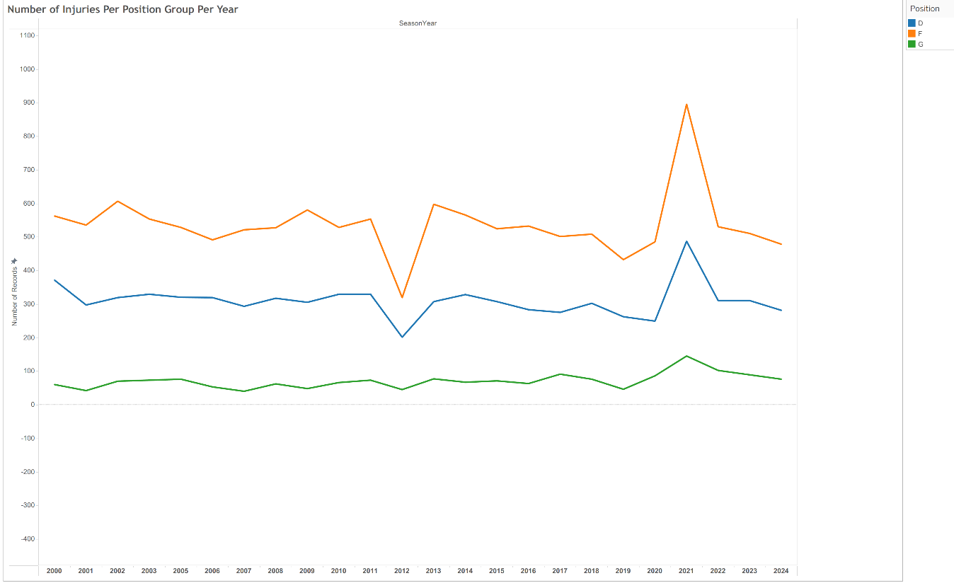
Figure 2: Line graph showing the total number of injuries by position group from the 2000-2001 NHL season to now. Visualization created using Tableau Software.

Evaluation of Guardian Caps in Collegiate and Professional Football
The results of the evaluation of the Guardian Caps at the collegiate level revealed two major conclusions. When Carratu tested both the treatment and control groups, he found that there were no statistically significant differences in test performance between the student-athletes who wore the Guardian Caps and the student-athletes who did not (Carratu). However, while the results were not statistically significant, student-athletes who wore the Guardian Caps had less variation on average for response speed, eye response constriction, and tracking ability during the visual response test (Carratu). These results may not be statistically significant, but they may be clinically significant given the health and safety setting of this research study.
The research study at the NFL level had similar findings. After the NFL required Guardian Cap usage for linemen, linebackers, and tight ends in 2022, the concussion rate for these players decreased by 54% (Funk, et al.). Although this was considered a remarkable effect, this sharp decline could not be solely attributed to the Guardian Cap NXT itself. Due to the multifactorial nature of injury, there may have been other factors at play (Funk, et al.).

Conclusion and Future Research
Many conclusions can be drawn from the statistical analyses conducted within this study. For now, findings are best to be interpreted on a sport-by-sport basis. For professional soccer players such as the athletes in the English Premier League from 2016-2021, the number of minutes played on the season and the number of days missed in the previous season were statistically significant in the multiple linear regression model with the dependent variable being the number of days missed on the current season due to injury. Other variables such as the athlete’s position and age may be considered clinically significant, depending on one’s interpretation. Defenders are predicted to miss the most days due to injuries, followed by midfielders, forwards, and then goalkeepers.
For college athletes who play a sport in the NCAA, there are several factors that may play a part in the athlete suffering from an injury during a training session. The most important factor is whether or not the athlete plays a sport (such as football) that consists of heavy contact. Football players are at a much higher risk of getting injured during a training session than athletes in other sports. Other factors that play a part in suffering from an injury include the athlete’s blood oxygen level percent, cumulative fatigue index, and the total impact of forces during the entire training session.
The analysis on the NFL injuries revealed some surprising results. Most fans and players think very poorly of synthetic playing surfaces such as turf, especially in the context of severe lower-limb injuries. Despite this, the analysis revealed that suffering a lower-limb injury on a synthetic surface is associated with a decrease in the likelihood of the injury requiring an absence of at least 42 days. A knee injury, as opposed to an ankle or foot injury, is predicted to greatly increase the probability of the injury requiring an absence of at least 42 days.
The NHL injury analysis from 2000-2001 to now indicated that forwards are the most prone to injury, followed by defensemen and then goaltenders. Lower-body and upper-body injuries were the most common during this time period, with forwards and defensemen additionally suffering from an increased number of knee injuries, shoulder injuries, and concussions. Fortunately, it appears as though injuries are gradually on the decline.
The Guardian Cap helmets in both collegiate and professional football have been correlated with some positive effects so far, but these findings cannot be considered statistically significant. Due to the multifactorial nature of injury and the recency of these helmets, the true effect of the Guardian Caps on head injuries and concussions cannot be determined as of now.
As expected, there were several internal and external factors that were considered significant in contributing to injuries, including severe ones. Despite this confirmation of the hypothesis, the results varied across each of the different sports that were studied. This suggests that the true conclusion about the factors that contribute to injuries in sports is dependent on the sport or activity that is being played.
Future research should be conducted in order to find the full population of injuries across all of the sports leagues that were analyzed in this study. Most of these analyses used just small samples from the full population, so finding the full extent of the data would allow for the best results. If this data can be found, then the estimates could become more accurate, and the models would hold higher relevance in predicting injuries and their severity.

Limitations
- Finding data for this project was difficult for a few reasons. First, many leagues are very private with their injury data, as they do not want to publicly make available data that describes how dangerous their league is. Second, many data sets were behind paywalls or restrictions that could not be bypassed. This made it difficult to find data for all leagues. The goal was to find data for more leagues, such as Major League Baseball (MLB), the National Basketball Association (NBA), and the National Association of Stock Car Auto Racing (NASCAR).
- Most of the data sets that were found tended to be samples of the full population of injuries in the given league. Interpreting the findings of these analyses requires an assumption that these samples are representative of the full population of injuries in the given sport.
- Originally, a few NBA data sets were acquired. The first showed the height, weight, and age of each player in NBA history. The other two data sets were transactional logs that showed when each player was placed on and removed from the Injured List. The goal was to merge the internal factors provided by the NBA with the two data sets that contained injury outcomes. In trying to merge these data sets into one, the data transformation step did not work properly in Microsoft Excel and Microsoft Power Query. This occurred because the players would appear on the Injured List every single day that they did not play across all seasons in the data set. This prevented the analysis of NBA injuries for this study, so a decision was made to pivot to National Hockey League (NHL) data instead.

Acknowledgements
I would like to give special thanks to everyone who aided me at any point during the process of completing this research study. First and foremost, I would like to thank Professor Bryan Crissinger, a Statistics professor in the Department of Applied Economics and Statistics within the University of Delaware College of Agriculture and Natural Resources. Professor Crissinger served as my faculty advisor for this project, which was submitted for STAT468: Senior Research Project, the capstone requirement for the undergraduate Statistics degree at the University of Delaware.
I would also like to thank Professor Patrick DeFeo, another professor from the University of Delaware College of Agriculture and Natural Resources. Professor DeFeo instructed STAT611: Regression Analysis in the spring of 2025, a course that was very beneficial for the regression analysis techniques used in this project. In particular, the coursework on binary logistic regressions and multicollinearity among predictors proved to be of great assistance for this project.
Finally, I would like to thank Professor Jack Davis, the Associate Director of Business Intelligence, Analytics, and Strategy at the University of Delaware Athletic Department. Professor Davis instructed SPAX402: Predictive Analysis with Athletics Data during the fall of 2025. This course provided me with experience with Microsoft Power Query, a key concept used in this project.

Sources
Literature Review Works Cited
Bahr, R, and I Holme. “Risk Factors for Sports Injuries -- a Methodological Approach.” British Journal of Sports Medicine, vol. 37, no. 5, 1 Oct. 2003, pp. 384–392, bjsm.bmj.com/content/37/5/384, https://doi.org/10.1136/bjsm.37.5.384. Accessed 27 Sept. 2025.
Carratu, Christopher. “Guardian Cap Effectiveness on Reducing Impact Accelerations and Enduring Player Health at the Collegiate Football Level.” Mit.edu, 23 June 2025, dspace.mit.edu/handle/1721.1/162566, https://hdl.handle.net/1721.1/162566. Accessed 7 Dec. 2025.
Funk, James R., et al. “An Analysis of Guardian Cap Use and Changes in the Concussion Rate in National Football League Preseason Practices from 2018 to 2023.” The American Journal of Sports Medicine, 2 July 2025, journals.sagepub.com/doi/full/10.1177/03635465251351288, https://doi.org/10.1177/03635465251351288. Accessed 7 Dec. 2025.
Nath, Debraj, et al. “View of Progress of Protective Gear in Preventing Sports Injuries.” Brazilianjournals.com.br, 2025, ojs.brazilianjournals.com.br/ojs/index.php/BRJD/article/view/67830/48261. Accessed 6 Dec. 2025.
Taimela, Simo, et al. “Intrinsic Risk Factors and Athletic Injuries.” Sports Medicine, vol. 9, no. 4, Apr. 1990, pp. 205–215, link.springer.com/article/10.2165/00007256-199009040-00002, https://doi.org/10.2165/00007256-199009040-00002. Accessed 27 Sept. 2025.
Wentao, Zhao. “Analysis of the Causes of Sports Injuries in Sports Training.” Frontiers in Sport Research, vol. 6, no. 1, 2024, francis-press.com/uploads/papers/GABe79pq5P7HyzaqpGLsIxYGW4JZwvH1lJHfA1eT.pdf, https://doi.org/10.25236/fsr.2024.060106. Accessed 27 Sept. 2025.

Data Set Links
- https://www.kaggle.com/datasets/ziya07/college-sports-injury-detection
- https://www.kaggle.com/datasets/kolambekalpesh/football-player-injury-data?resource=download
- https://www.kaggle.com/code/jaseziv83/an-analysis-of-nfl-injuries
- https://nhlinjuryviz.blogspot.com/p/index-page.html

Appendices
Appendix A: Data Dictionary for Raw Data Set of 2016-2021 English Premier League Injuries
Variable | Description and Units
p_id2 | Name of player
start_year | Year of observation
season_days_injured | Number of days missed in the season due to injury
total_days_injured | Total days missed across all six seasons
season_minutes_played | Number of minutes player received on the field for the current season
season_games_played | Number of matches player participated in for the current season
season_matches_in_squad | Number of matches the player’s team had in current season
total_minutes_played | The total number of minutes the player received across all six seasons
total_games_played | Total number of matches the player participated in across all six seasons
dob | Date of birth of player, shown in m/dd/yyyy format
height_cm | Player’s height in centimeters from FIFA 16-21
weight_kg | Player’s weight in kilograms averaged across FIFA 16-21
nationality | Player’s country of origin
work_rate | Categorical variable from FIFA 16-21 grading how hard the player works during matches; high, medium, or low
work_rate_numeric | Player’s work-rate mode across FIFA 16-21 ranging from 2-4 in 0.5 intervals
pace | Player’s ‘pace’ rating averaged across FIFA 16-21
physic | Player’s ‘physical’ rating averaged across FIFA 16-21
fifa_rating | Overall grade assigned to player by FIFA 16-21; averaged across every video game player appeared in
position | Player’s soccer position: Defender, Forward, Midfielder, or Goalkeeper
position_numeric | ‘Goalkeeper’: 0, ‘Defender’: 1, ‘Forward’: 2, ‘Midfielder’: 3
age | Player age in relevant season
cumulative_minutes_played | Cumulative minutes played by player in all previous seasons
cumulative_matches_played | Cumulative number of matches played by player in all previous seasons
minutes_per_game_prev_seasons | Average minutes player per game in all previous seasons
avg_days_injured_prev_seasons | Average calendar days injured in all previous seasons
avg_games_per_season_prev_seasons | Average number of games played participated in during previous seasons
bmi | Body mass index of player
significant_injury_prev_season | Whether player had significant injury in previous season; 1 for injury and 0 for no injury
cumulative_days_injured | Cumulative calendar days player was injured prior to current season
target_major_injury | Whether player had major injury in current season; True = yes, False = no
season_days_injured_prev_season | Number of days missed due to injury in the previous season
Table A.1: Data dictionary for the raw 2016-2021 EPL injury data from ‘Kalpesh Kolambe’ on Kaggle.
Appendix B: Data Dictionary for Raw NCAA Training Sessions
Variable | Description and Units
Athlete_ID | Unique numerical ID for each student-athlete
Sport_Type | The type of sport the athlete is engaged in (soccer, basketball, etc.)
Session_Date | Date of the training session, written in yyyy-mm-dd
Heart_Rate_BPM | Heart rate in beats per minute, averaged across the entire session
Respiratory_Rate_BPM | Respiratory rate in breaths per minute, averaged across the entire sessions
Skin_Temperature_C | Athlete’s skin temperature in degrees Celsius, averaged across the entire session
Blood_Oxygen_Level_Percent | Percentage of blood oxygen saturation, averaged across the entire session
Impact_Force_Newtons | Cumulative force of impact during the training session, measured in Newtons
Cumulative_Fatigue_Index | A calculated index representing the athlete’s cumulative fatigue level
Activity_Type | Type of activity performed during the session (Sprinting, Jumping)
Duration_Minutes | Duration of the training session in minutes
Injury_Risk_Score | A calculated score representing the risk of injury
Injury_Occurred | Binary variable indicating whether an injury during the session (1 for injury, 0 for no injury)
Table B.1: Data dictionary for the raw NCAA injuries data set from ‘Ziya’ on Kaggle.

Appendix C: Data Dictionary for Raw NFL Lower-Limb Injuries
Variable | Description and Units
PlayerKey | The anonymous ID of the athlete who was injured
GameID | The ID of the game that the player was injured in (i.e. 39873-4)
PlayKey | The ID of the play that the player was injured in (i.e. 39873-4)
BodyPart | Body part injured during the play (knee, ankle, or foot)
Surface | Playing surface that the injury occurred on (synthetic or natural surface)
DM_M1 | Binary variable representing if the player missed at least 1 day (1 if the player did, 0 if the player missed 0 days)
DM_M7 | Binary variable representing if the player missed at least 7 days (1 if the player did, 0 if not)
DM_M28 | Binary variable representing if the player missed at least 28 days (1 if the player did, 0 if not)
DM_M42 | Binary variable representing if the player missed at least 42 days (1 if the player did, 0 if not)
Table C.1: Data dictionary for the raw NFL external factors data set. Provided by Jason Zivkovic on Kaggle.

Appendix D: Data Dictionary for Raw NHL Injury Outcomes
Variable | Description and Units
Season | Season that injury occurred in (i.e. 2000-2001)
Team | Injured player’s team at the time of injury
Position | Player’s position: Forward (F), Defenseman (D), or Goaltender (G)
Injury Type | Body part injured during the play or the specific name of the injury
Player | Name of injured player, written in Last, First format
Cap Hit | The cap hit of the injured player in United States dollars (USD)
Chip | Cost of any cap-related mechanisms for injured player, measured in United States dollars
Games Missed | Number of games the player missed due to injury
Table D.1: Data dictionary for the raw NHL injuries data set. Provided by NHL Injury Viz online.

Appendix E: Residual Analysis of EPL Multiple Linear Regression
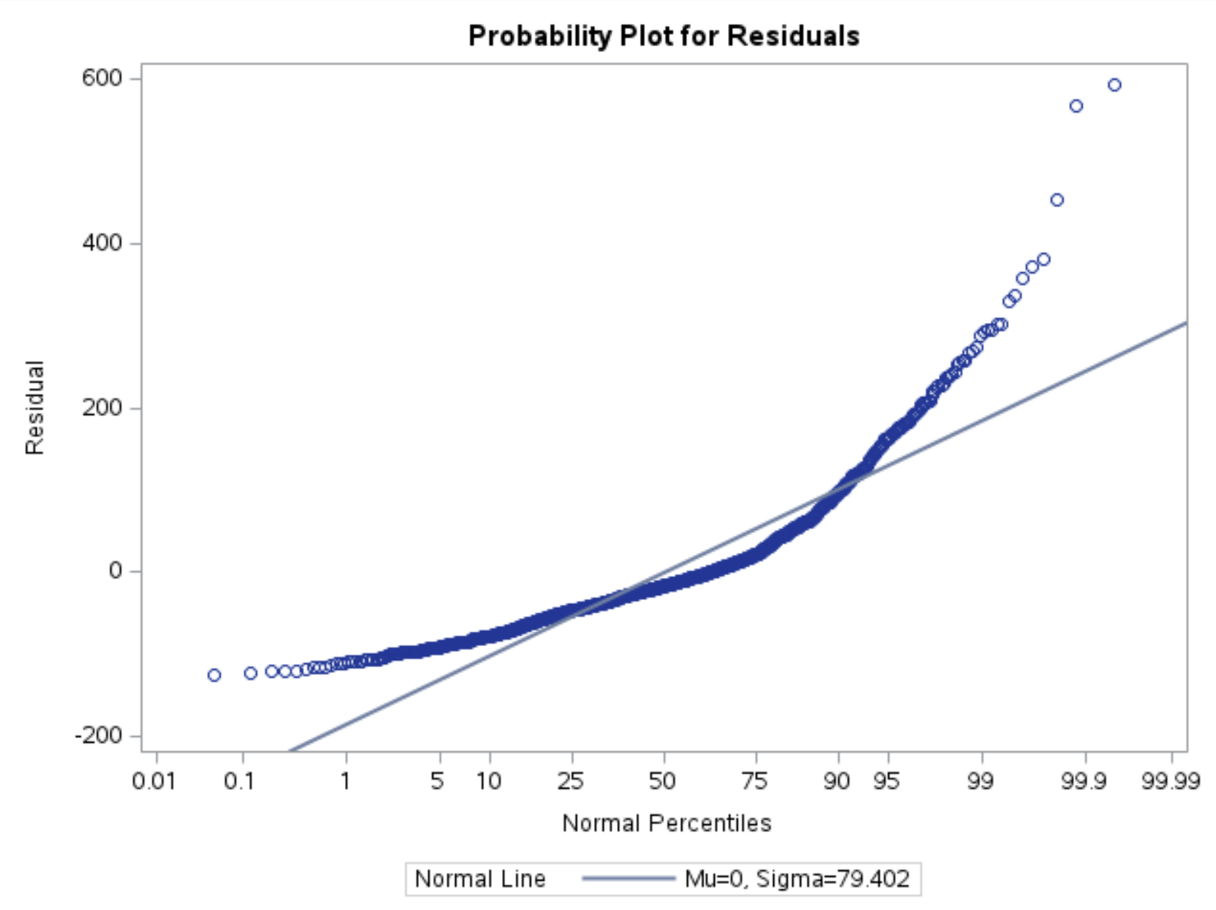
Figure E.1: Normal probability plot of residuals for the English Premier League multiple linear regression. Generated using Statistical Analysis Software (SAS).

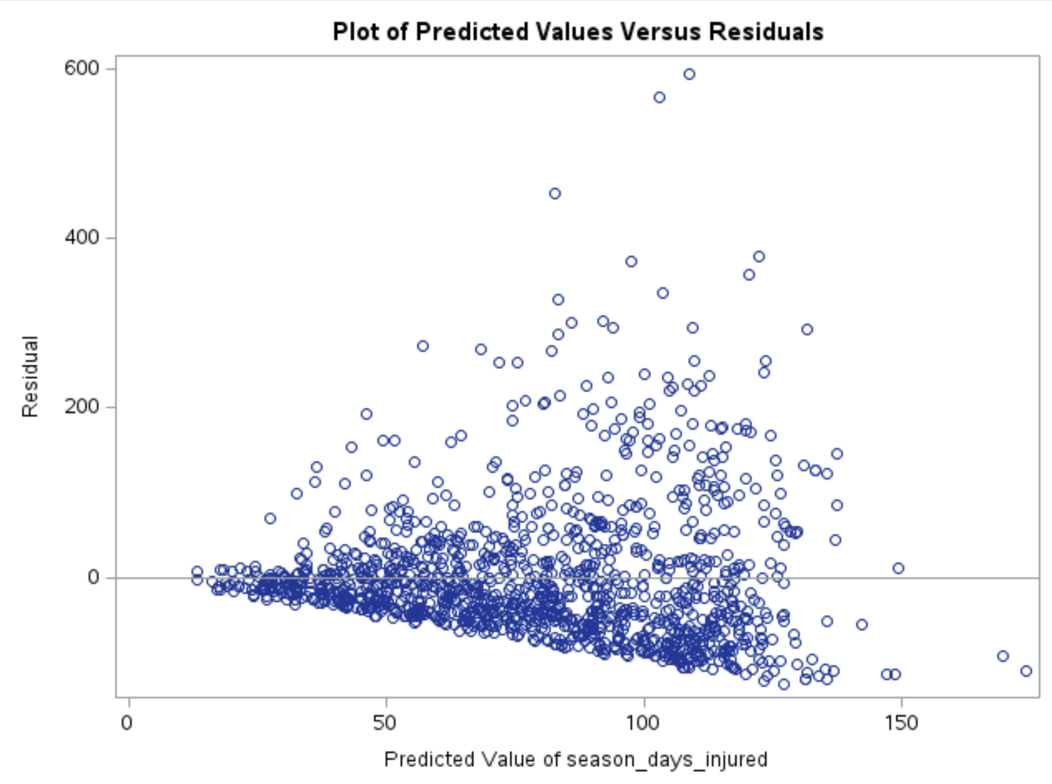
Figure E.2: Plot of predicted values versus residuals for the English Premier League multiple linear regression. Generated using Statistical Analysis Software (SAS).

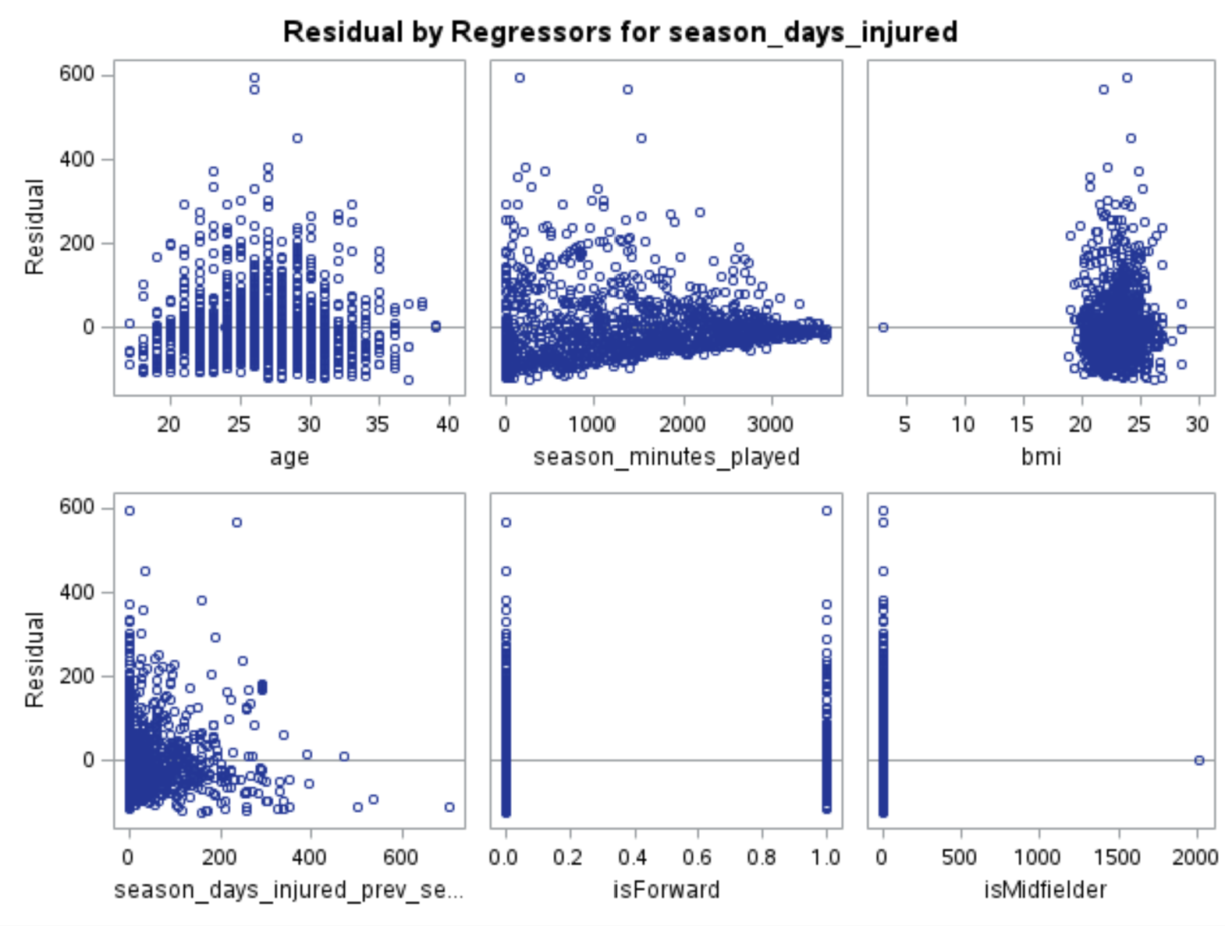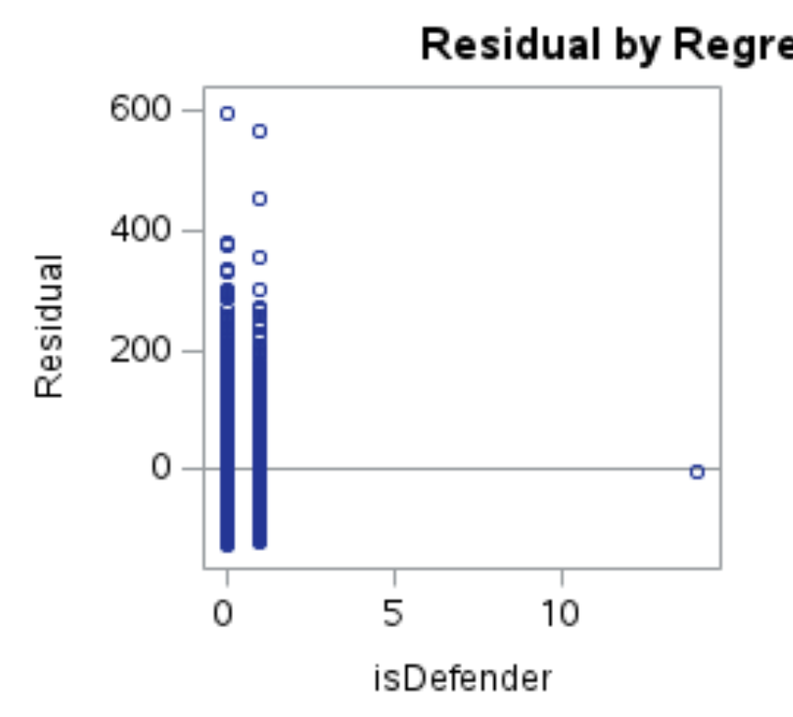
Figure E.3: Plot of residuals by regressor for the English Premier League multiple linear regression. Generated using Statistical Analysis Software (SAS).

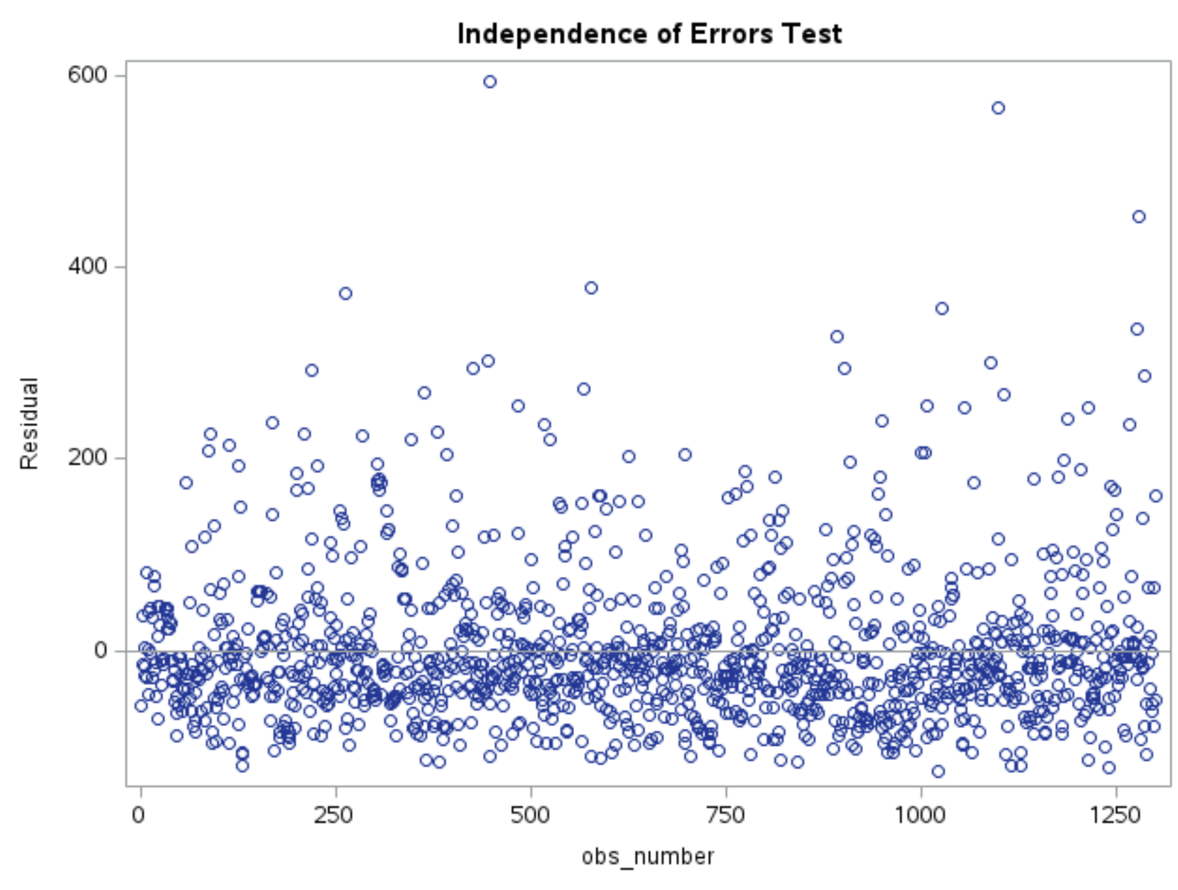
Figure E.4: Independence of errors test for the English Premier League multiple linear regression. Generated using Statistical Analysis Software (SAS).

Appendix F: Multicollinearity Results for NCAA Injuries Regression
Variable | Coefficient | P-Value | Variance Inflation Factor
Intercept | -5.86668E-7 | 0.9918 | 0
Heart_Rate_BPM | 0.00036219 | <.0001 | 36.64990
Respiratory_Rate_BPM | -0.00200 | <.0001 | 59.61163
Skin_Temperature_C | 0.01094 | <.0001 | 2860.87175
Blood_Oxygen_Level_Percent | -0.00182 | 0.0003 | 2742.85746
Impact_Force_Newtons | 0.00131 | <.0001 | 8.94112
Cumulative_Fatigue_Index | 0.41898 | <.0001 | 9.15462
Duration_Minutes | 0.00031193 | <.0001 | 8.47816
isHeavyContact | -0.07838 | <.0001 | 1.51904
isMildContact | 0.00560 | 0.0070 | 2.02186
isIntense | 0.02583 | <.0001 | 1.71098
Table F.1: Variance Inflation Factors (VIFs) for the binary logistic regression using the NCAA training sessions. Generated using Statistical Analysis Software (SAS).

Number | Eigenvalue | Condition Index | Heart_Rate_BPM | Respiratory_Rate_BPM | Skin_Temperature_C | Blood_Oxygen_Level_Percent
1 | 7.74753 | 1.00000 | 0.00043851 | 0.00027170 | 0.00000573 | 0.00000597
2 | 1.00139 | 2.78151 | 4.881004E-7 | 3.095158E-8 | 1.76122E-10 | 6.87994E-11
3 | 0.55285 | 3.74349 | 0.00035429 | 0.00020400 | 0.00000488 | 0.00000512
4 | 0.36973 | 4.57764 | 0.00083311 | 0.00036393 | 0.00000868 | 0.00000918
5 | 0.11495 | 8.20983 | 0.00062031 | 0.00072536 | 0.00000644 | 0.00000702
6 | 0.10520 | 8.58173 | 0.00015040 | 0.00001162 | 8.56122E-10 | 5.54759E-10
7 | 0.07592 | 10.10170 | 0.05552 | 0.02787 | 0.00032844 | 0.00034863
8 | 0.02267 | 18.48661 | 0.77078 | 0.22608 | 0.00038635 | 0.00042452
9 | 0.00958 | 28.43940 | 0.16778 | 0.74084 | 0.00901 | 0.01011
10 | 0.00018030 | 207.29228 | 0.00352 | 0.00363 | 0.99025 | 0.98909
Table F.2: Multicollinearity eigenvalues for the binary logistic regression using the NCAA training sessions. Generated using Statistical Analysis Software (SAS).

